Project Design Phase
Solution Architecture

Date | 28 February 2026
Team ID | LTVIP2026TMIDS87250
Project Name | Smart Sorting: Transfer Learning for Identifying Rotten Fruits and Vegetables
Maximum Marks | 4 Marks

Solution Architecture:
Solution architecture is a complex process – with many sub-processes – that bridges the gap between business problems and technology solutions. Its goals are to:
● Find the best tech solution to solve existing business problems.
→ Implement a deep learning–based image classification system using transfer learning to accurately detect and classify rotten vs. fresh fruits/vegetables, addressing inefficiencies in manual sorting.
● Describe the structure, characteristics, behaviour, and other aspects of the software to project stakeholders.
→ The system comprises components such as image input (camera/UI), model inference engine, sorting/display interface, and storage/logging. Images are captured, processed, classified, and then routed or logged based on classification results.
● Define features, development phases, and solution requirements.
→ Key features include image upload or real-time capture, automatic freshness detection, visual dashboard or hardware-based sorting, and database logging. Development phases include data collection, model training, backend integration, and deployment.

Example - Solution Architecture Diagram:

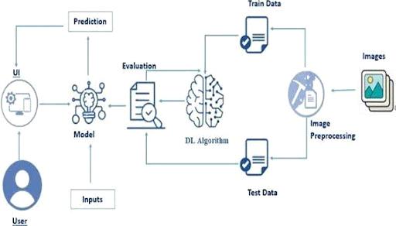

Figure 1: Architecture of Smart Sorting: Transfer Learning for Identifying Rotten Fruits and Vegetables
Reference:
- A Deep Learning Approach to Fruit and Vegetable Classification: Fresh or Rotten” by Gulsum Kayhan (Medium, May 19, 2025) – this blog clearly outlines a transfer‑learning project using ResNet to classify 14 types of fresh vs rotten produce, with implementation details and visuals

